Design Doc Template

*Author(s): S.Praveena*

*s.Anusha*

*s.Harshavi*

*Date: 22/05/2019*

Revision: 0

Document Status: Draft [Draft, Completed, Submitted, Reviewed, Final]

Project Status: In-Progress [In Review, Approved, In-Progress, Completed]

Revision History

|  |  |  |  |
| --- | --- | --- | --- |
| Date | Revision | Description | Author |
| 22/05/2019 | 0 | Initial draft of the design doc template | xyz |
|  |  |  |  |
|  |  |  |  |
|  |  |  |  |
|  |  |  |  |
|  |  |  |  |
|  |  |  |  |
|  |  |  |  |
|  |  |  |  |
|  |  |  |  |

Table of Contents

TOC \o "1-3" \h \z \u Introduction4

Summary4

Background4

Definitions, Acronyms, and Abbreviations4

Design Overview4

Requirements4

Documentation4

Minimum Viable Product5

Stretch goals5

Future work5

Architectural Diagrams5

System Diagrams5

Application Programming Interface5

Recommendations5

User Interface6

Data Models and Storage6

Service Operability6

Key Performance Indicators6

Service Level Objectives6

Project Overview7

Communication and Tracking7

Risks7

Milestones7

Project Phases7

Cost7

Frequently Asked Question7

References7

Addendum8

# Introduction

## Summary

* The main intension of this project is to find the accident spot at any place and intimating it to ambulance through the GPS and GSM networks.

## Background

* When an accident occurs, the piezoelectric plate gives the electrical signal to MC.

## Definitions, Acronyms, and Abbreviations

* Global System for Mobiles(GSM) technology is used to establish cellular corrections.
* GPS is used to trace the position of the vehicle.

# Design Overview

## Requirements

* Power supply and Vibration sensor
* Micro controller
* Liquid crystal display
* Keypad and DB9 connector
* DPDT relay
* GPS module
* GSM module

### Documentation

## Future work

This can be developed by interconnecting a camera to the controller module that takes the photograph of the accidents spot that makes the tracking easier.

# System Diagrams

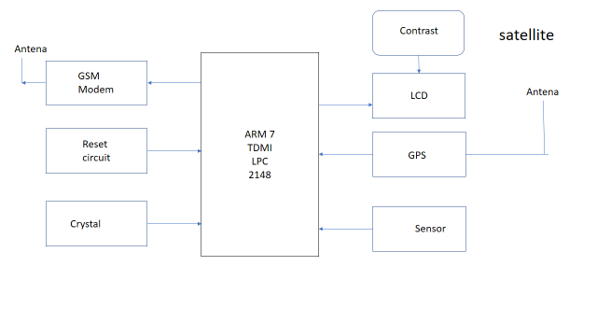

# Application Programming Interface

Car security system.

Wireless security system.

Automation system.

Remote keyless entry

# User Interface

GPS and GMS are used

# Project Overview

## Communication and Tracking

* When an accident occurs, the piezoelectric plate gives the electrical signal to MC.
* MC switches GSM and GPS network by using DPDT switch.
* GPS receiver takes latitude and longitude through antenna.
* GSM transmitter sends this information to control system.

## Risks

The biggest problem is the blockage of signal transmission by mountains , high building , tunnels

## Milestones

It will be completed on June ending.

## Cost

GSM – 1,999rs

GPS - 842rs

Buzzer – 90rs

Mercury – 599rs

LCD – 1,806rs

SIM adapter- 199rs

Total – 5,535

# Frequently Asked Question

Which GSM modem is used in this project?

Can we add sensors with this project?

# References

[www.Ask.com](http://www.Ask.com).

[www.EngineersGarage.com](http://www.EngineersGarage.com)

Google images.